M E D I A A L E R T

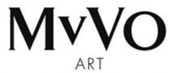

AD ART SHOW 2022
All-Digital Art Exhibit Returns to the Iconic Oculus
Westfield World Trade Center in New York City
May 1- 31, 2022

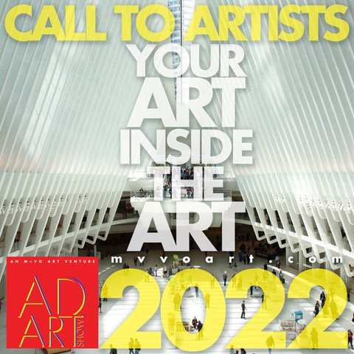
MvVO ART AD ART SHOW 2022 Call for Artists (photo credit MvVO)

Call for Artists Begins Now!

MvVO ART, creator of AD ART SHOW, announced the Call for Artists for the 2022 edition of AD ART SHOW. Artists working in advertising, design and related fields are invited to apply to participate in AD ART SHOW 2022. The Call for Artists begins now! Go to www.mvvoart.com for application details and to apply.

AD ART SHOW is a unique experience bringing ART directly to people by transforming an advertising platform—monumental digital screens—into a public gallery space for an entire month. The artists of AD ART SHOW have a background in advertising/design and related fields. They are following in the footsteps of famous artists like Andy Warhol, Rene Magritte, and Keith Haring who also had a commercial practice. Historically some artists have made the leap, but the barriers persist; and AD ART SHOW throws the doors open for these talented artists with direct connections to the Art world in a celebration of artistic discovery open to all art lovers.

For the 2022 edition, AD ART SHOW is returning to the Oculus in the Westfield World Trade Center in New York City—a transit hub, shopping destination, and an iconic NYC architectural landmark by Santiago Calatrava. AD ART SHOW 2022 will exhibit artworks—paintings, sculpture, photography, and mixed media works—on the monumental, high-impact digital advertising screens from May 1 to May 31, 2022.

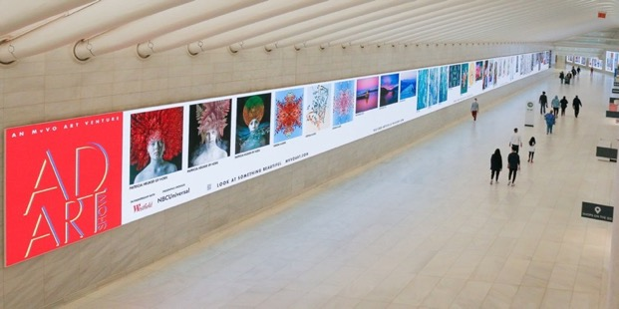
MvVO ART AD ART SHOW 2021 at the Oculus at Westfield World Trade Center (photo credit Olivia Olsen)

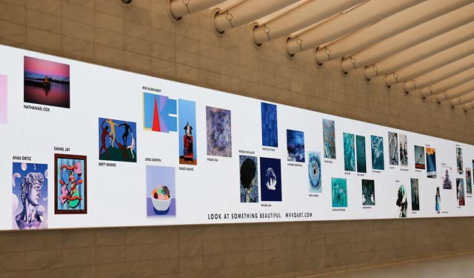
MvVO ART AD ART SHOW 2021 at the Oculus at Westfield World Trade Center (photo credit Olivia Olsen)

AD ART SHOW combines the powerful engagement of an electronic advertising medium with the experience of Art. It’s a winning combination of audience, Art, and platform, inside a popular shopping and dining destination.

Works by AD ART SHOW artists are also exhibited on the MvVO ART Artsy gallery page. Artsy—the premiere art market site for collectors—offers artists another avenue for discovery.

“AD ART SHOW bridges the gap between the Art world and advertising by championing the artists working in advertising and celebrating their work,” said Maria van Vlodrop, MvVO ART Founder, named a Top Ten Cultural Shaper by ADWEEK magazine in its annual Creative 100 List.

MvVO ART’s —selection committee (2021 selection committee) a who’s who of contemporary art experts and globally recognized creative pioneers—vets all the artists included in the show. A jury of well-known Art collectors selects the show winners. Artists with top honors receive additional Art world exposure and prizes.

AD ART SHOW launched in 2018 at Sotheby’s New York and went all digital in 2019, 2020, and 2021 in the Oculus at the Westfield WTC. MvVO ART continues to innovate with each addition of the show, adding new opportunities for artists.

For more information about AD ART SHOW 2022 and to see works by the 2021 artists www.mvvoart.com and follow MvVO ART on Instagram: www.instagram.com/mvvoart/.

For hi-res images, visit: https://bit.ly/2YQ2GbB

About MvVO ART:
MvVO ART, creator of AD ART SHOW (the art of artists from advertising) is a New York based innovative art venture dedicated to creating new opportunities for artists, art lovers & brands to discover each other and form powerful partnerships. MvVO ART’s Founder & CEO, Maria van Vlodrop is in Adweek’s 100 Creative list as top ten cultural shaper in the pandemic and beyond.

Website: http://mvvoart.com
Instagram: https://www.instagram.com/mvvoart/
Maria van Vlodrop: https://www.linkedin.com/in/maria-van-vlodrop-4010392/

About The Westfield Network:
Launched in 2017, The Westfield Network is the largest digital out-of-home media network in the U.S. that features real-time capture of consumer engagement and demographics. It provides meaningful analytics to optimize advertising content, making it more relevant and engaging for the customers in proximity to a screen at any given time. More than 400 brands in leading consumer retail, luxury, entertainment, and telecom have advertised on the network to date.

PRESS CONTACT (MvVO ART):
Norah Lawlor | Lawlor Media Group | www.lawlormediagroup.com
Norah@lawlormediagroup.com | Tel: (212) 967-6900
F: LawlorMediaGroup | I: lawlormedia | T: @LawlorMedia

